**PROJECT REPORT TEMPLATE TEAM ID-NM2023TMID04417**

**1.INTRODUCTION:**

**1.1PROJECT OVERVIEW:**

Salesforce event management is a**cloud-based solution** that can help to manage multiple events. It includes all the employees responsible for selling and marketing products or services.

We Created

EVENT MANAGEMENT APP

Objects and fields for APP

**2.PROJECT DEFINATION AND DESIGH THINKING:**

**2.1 EMPATHY MAP:**

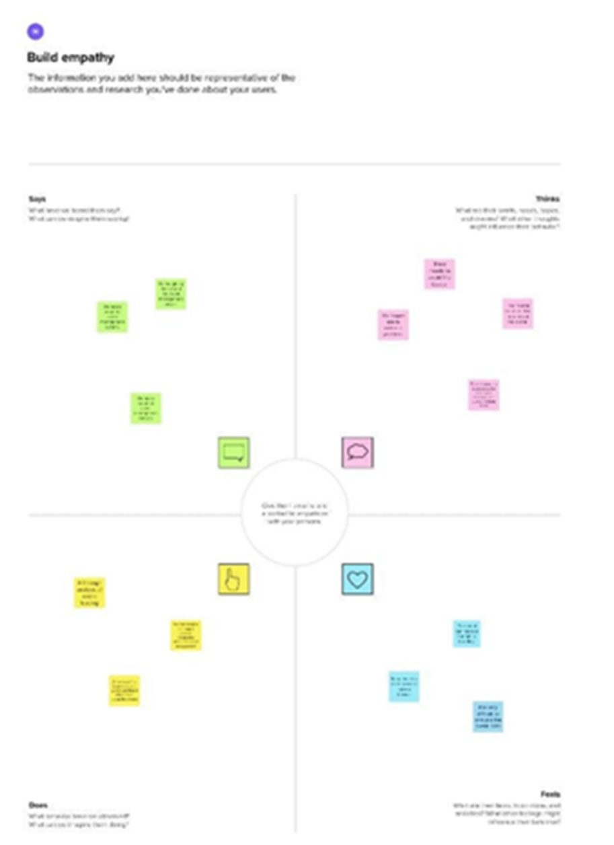

**2.2 IDEATION AND BRAINSTROMING MAP:**

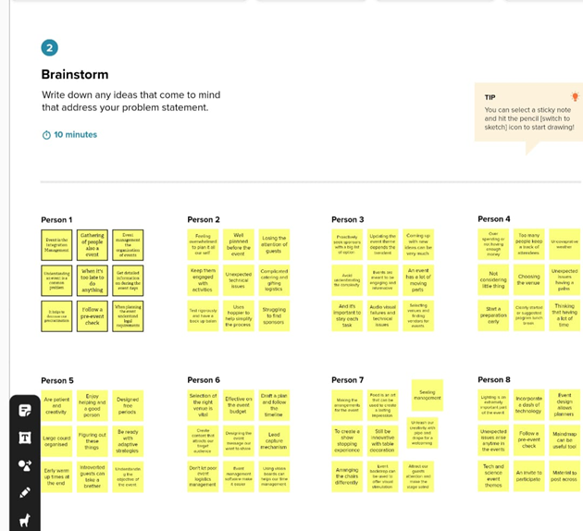

**3. RESULTS:**

**3.1 DATA MODEL**

|  |  |  |
| --- | --- | --- |
| OBJECT NAME | **FIELD IN THE OBJECT** | |
| **FILED LABLE** | **DATA TYPE** |
| ***EVENT*** | **city** | **text** |
| **Start date** | **Date/time** |
| **Event name** | **Master-detail relationship** |
| ***ATTENDEE*** | **Id** | **Auto number** |
| **phone** | **phone** |
| **Tickets** | **picklist** |
| ***SPEAKER*** | **bio** | **Text area** |
| **email** | **email** |
| ***VENDORS*** | **phone** | **phone** |
| **Service provider** | **text** |
| **Event name** | **Look-up relationship** |

**3.2 ACTIVITY AND SCREENSHOT:**

**Milestone-1[ salesforce] :**

**A developer org is created in salesforce .signup from is filled and a new user name and password is created .account is activated by the email received and the account gets verified and a developer account gets created.**

**Milestone-2[object] :**

**Activity1:[Creating Event object]**

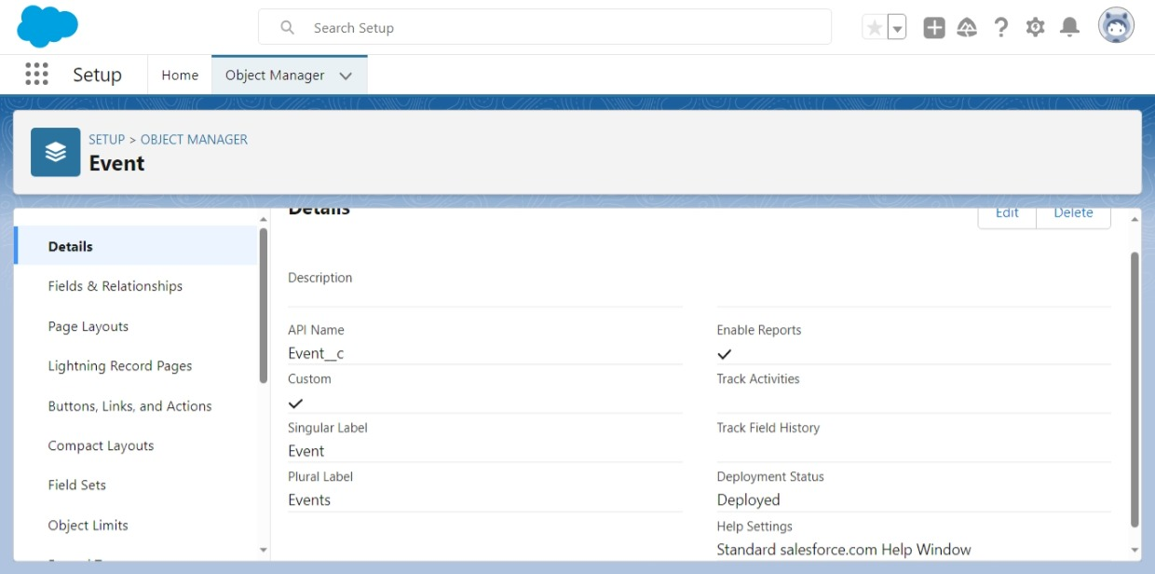

**Activity-2[creating attendee object]**

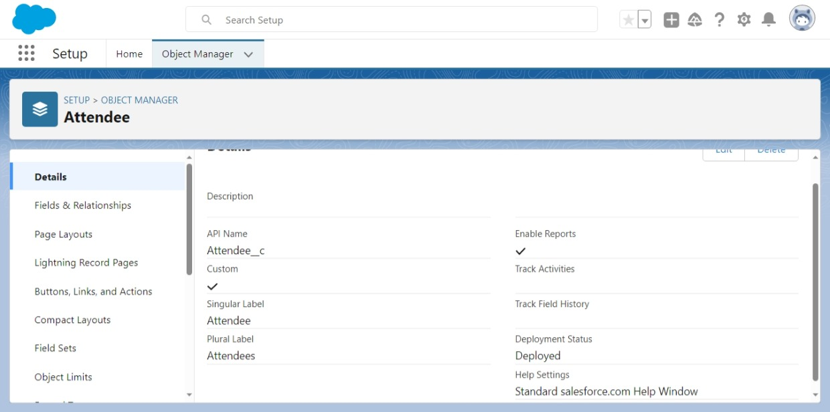

Activity-3[Creating Speaker Object]

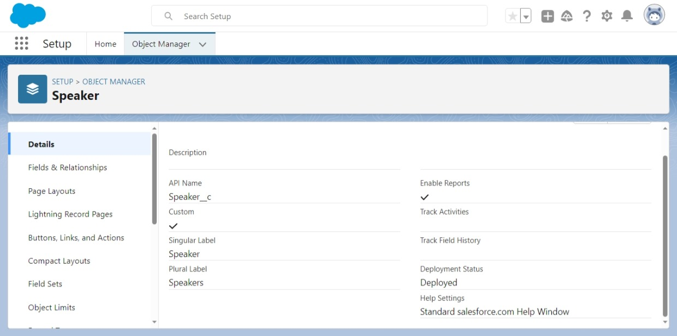

Activity-4[Creating Vendor Object]

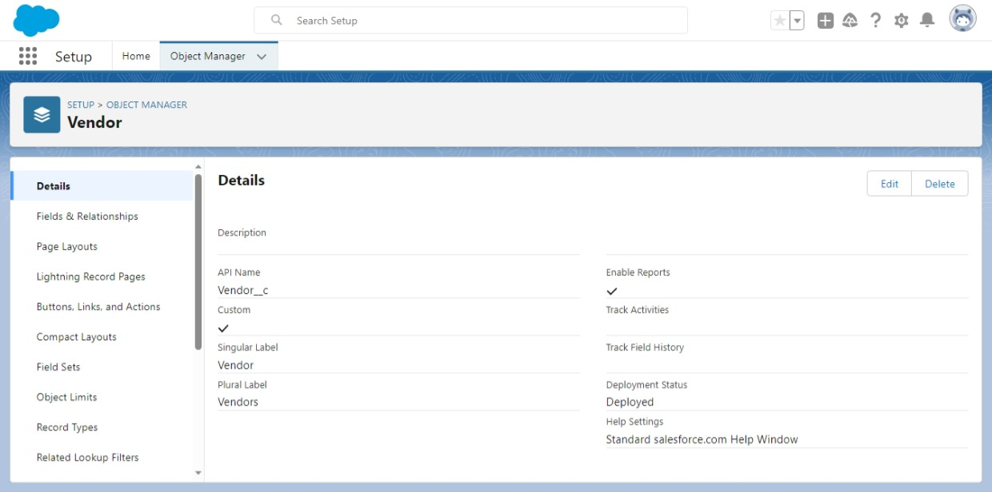

Milestone-3

1. Tab :

Activity :[creating the event,attendee,speaker and vendor tabs]

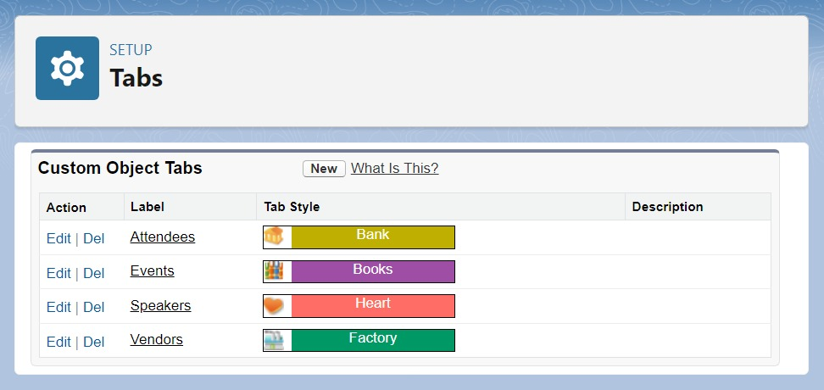

2.Application :

Activity :[Creating for Lightning App]

A new lightning app named as EVENT MANAGEMENT APP is created .this can be viewed in app launcher.

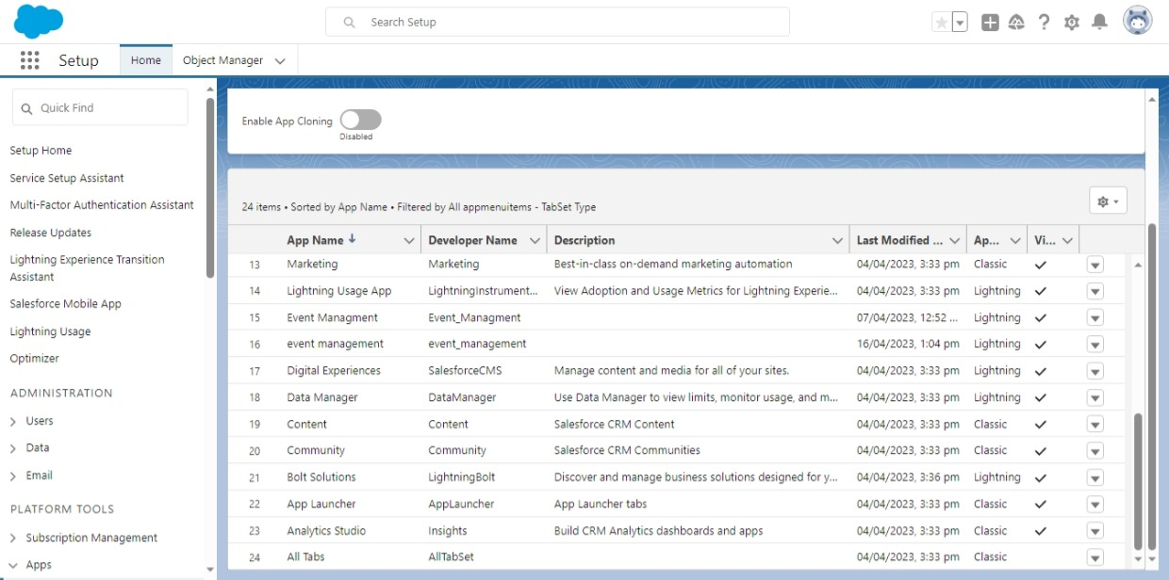

Milestone-4:

Activity -1:[creating for field and relationship]

EVENT OBJECT:

Event field are using lookup(user),master-detail(speaker),text data types are created.

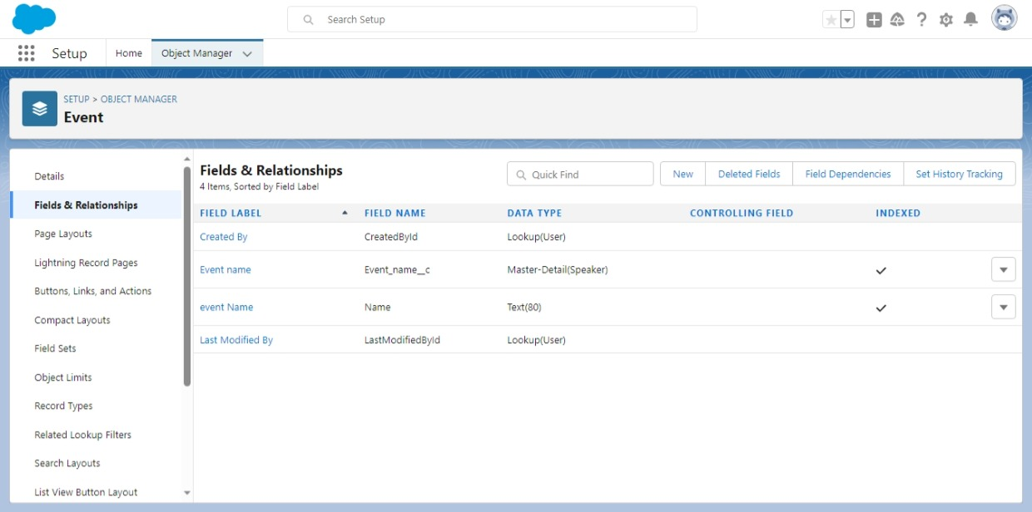

ACTIVITY-2: Attendee object

Attendee fields using text, email, phone and lookup data types are created.

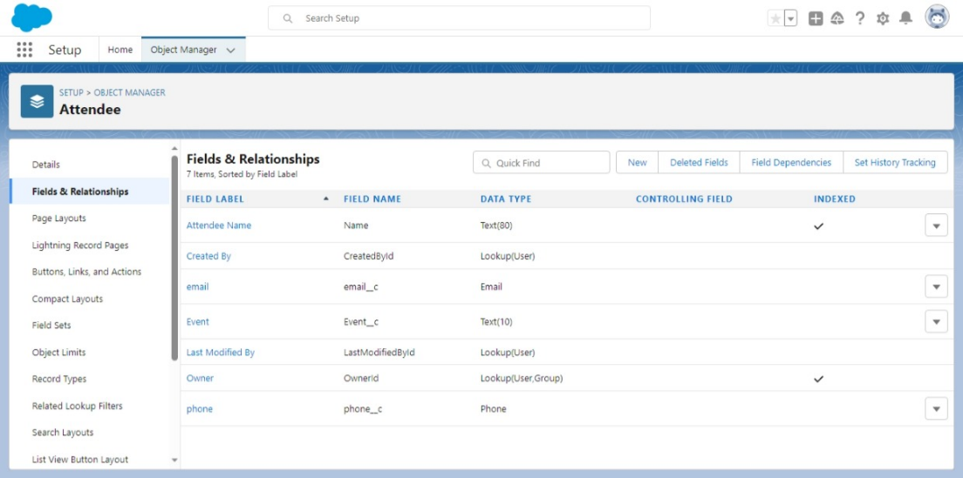

ACTIVITY-3 :

Speaker Object

Speaker fields using text, text area, phone, lookup data type are created.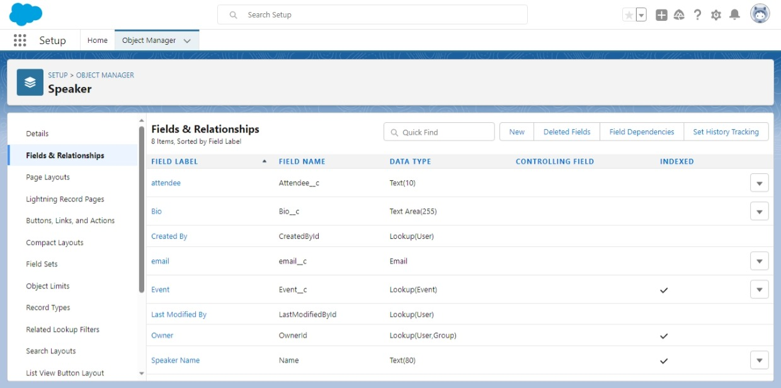

ACTIVITY-4 :

Vendor Object

Vendor fields using lookup, email, phone, text data type are created.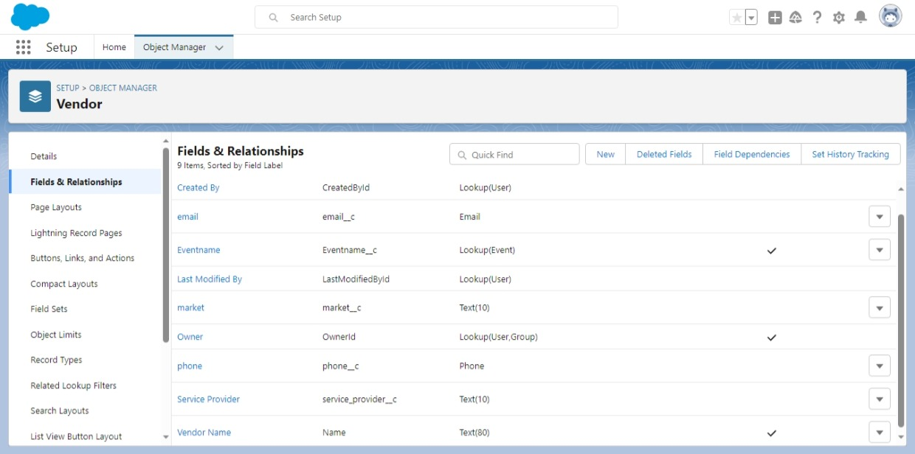

MILESTONE-5:( Profiles)

ACTIVITY : (creating the profile)

We are created the EVENT USER profile.

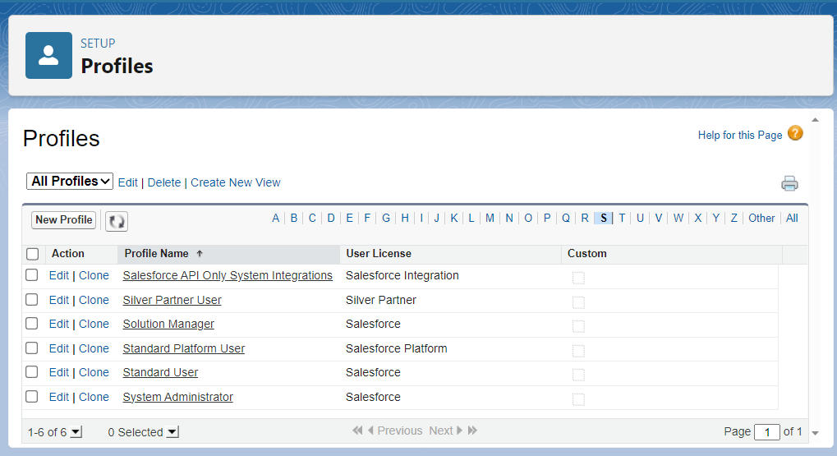

MILESTONE -6 :(Creating the users)

Using the tab a new profile, salesforce user is created.

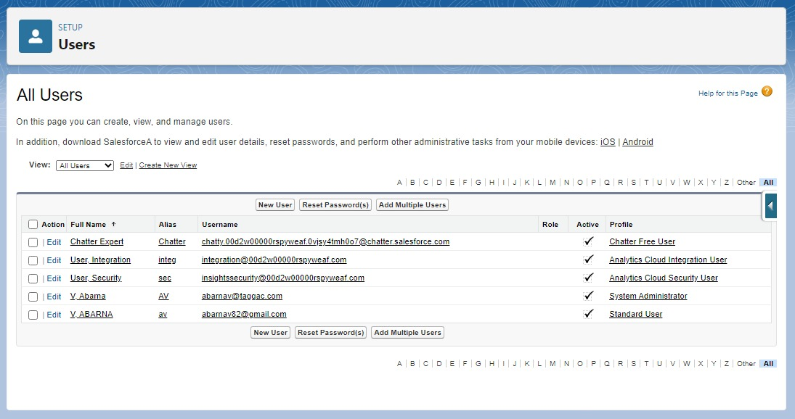

MILESTONE-7 (Permission sets)

the permission sets tab as created the Event permits.

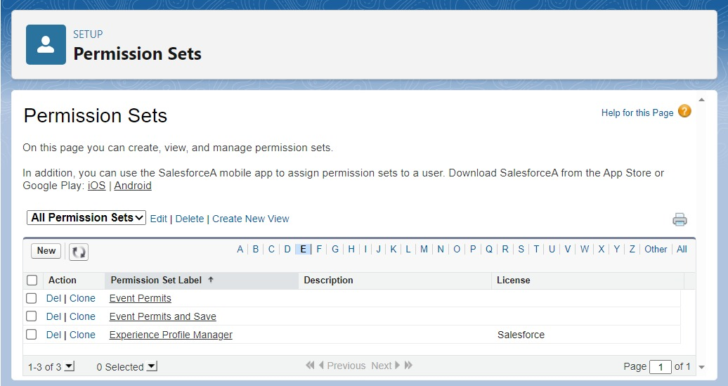

MILESTONE -8 :(Creating a report)

We are created the ATTENDEES WITH EVENTS FOR THE REPORTS.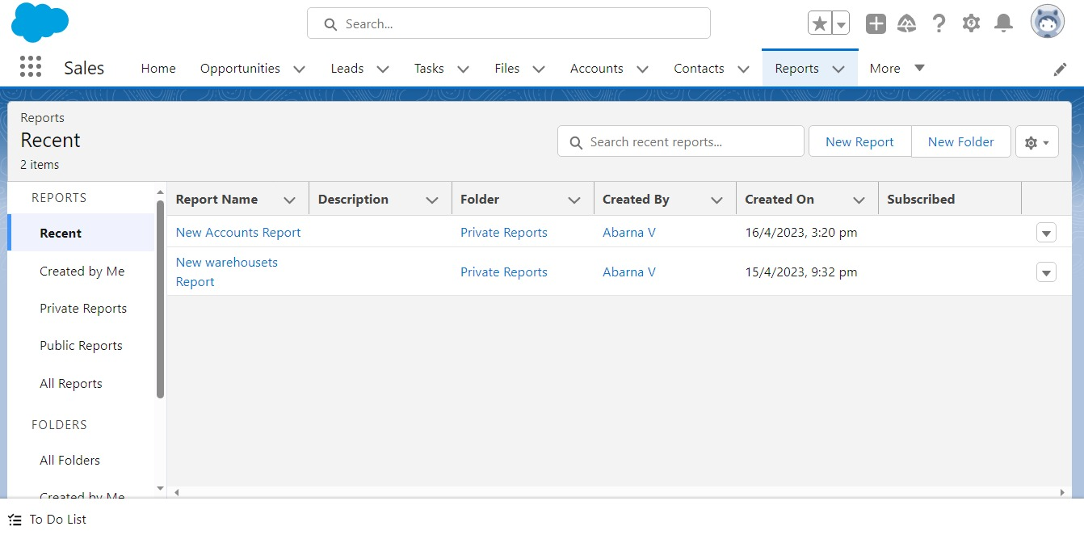

**4.**Trailblazer Profile URL:

Team lead (ABARNA.V) – <https://trailblazer.me/id/abarv22>

Team member 1 (ANITHA.P) – <https://trailblazer.me/id/anitp12>

Team member 2 (GOKULAPRIYA.R) – <https://trailblazer.me/id/o9ehs2ik>

Team member 3 (NIRMALA.R) – <https://trailblazer.me/id/nirmalar>

Team member 4 (YOGALAKSHMI.E) - <https://trailblazer.me/id/eyogalakshmi>

**5.ADVANDAGES AND DISADVANDAGES:**

**Salesforce and good customer service comes hand in hand.**

**The data base that salesforce uses is also helpful in digitizing and organizing company sales records.**

**Users can also loss a personal touch as in the process of automation.**

**Salesforce contains barriers to adoption.**

**6.APPLICATIONS:**

**Minimize administration efforts.**

**Eliminating missed communications.**

**Digitize how our events are run.**

**Access detailed reports and analytics.**

**7.FUTURE SCOPE:**

**Hosting events can redesign the structure of a city by facilitating economic growth, employment, opportunities, urban development, and promoting indigenous culture and heritage.**

**8.CONCLUTION:**

**To created new object and fields.**

**Event management system is user friendly and costeffective system, it is customised with activities related to event management life-cycle.**